Spectral coherence: GBPUSD and AUDUSD
Method 21 / daily log returns / Welch magnitude-squared coherence / Alpari D1 full available history

Study setup
Logical pair: GBPUSD , AUDUSD
Broker symbols: GBPUSD_i , AUDUSD_i
Snapshot: 2026-11-03_majors_alpari_D1
Timeframe: D1
Matched return window: 1999-01-05 to 2026-11-02 (UTC bar dates)
Matched return count n: 7228
Dropped unfinished last bar dated 2026-11-03 UTC after a tick-volume check against the prior complete day.
Welch: fs=1.0, nperseg=256, noverlap=128, window=hann, detrend=constant
Headline: gamma^2 nearest f=1/5; also 1/21 and 1/63
Complete matched rows (Excel): GBPUSD-AUDUSD_Spectral_D1.xlsx
Complete matched rows (HTML table): GBPUSD-AUDUSD_Spectral_D1_data.html

Method carried forward
Magnitude-squared spectral coherence gamma^2(f) measures shared linear power between matched daily log returns of close, ln(close_t / close_t-1), at each frequency f (cycles per day). Quotes are not inverted. Welch settings are frozen: fs=1, nperseg=256, noverlap=128, window=hann, detrend=constant. Headline is gamma^2 at the frequency bin nearest f=1/5 (five-day cycle from the formula sheet). Also reported: gamma^2 nearest f=1/21 and f=1/63, mean gamma^2 over the frequency grid, and phase of the cross-spectrum at the 1/5 bin. Coherence is unsigned (0 to 1); phase carries timing. Same-sample Pearson r is a side check only. This is not causation and not a trading signal.

Results (headline)
gamma^2 near 1/5: 0.313920
bin f (1/5): 0.199219
phase at 1/5 (rad): 0.174201
gamma^2 near 1/21: 0.378064
gamma^2 near 1/63: 0.294951
mean gamma^2: 0.316287
Pearson r: 0.539048

Target-frequency summary
period | target_f | f_bin | gamma2 | phase_rad
5 | 0.2 | 0.19921875 | 0.31391987 | 0.17420079
21 | 0.04761905 | 0.046875 | 0.37806377 | 0.15553858
63 | 0.01587302 | 0.015625 | 0.29495112 | 0.39564406

Conclusion
Headline gamma^2 near f=1/5 for GBPUSD and AUDUSD: 0.3139 (bin f=0.199219, phase=0.1742 rad). At ~1/21: 0.3781; at ~1/63: 0.2950. Mean gamma^2 = 0.3163. Pearson r = 0.5390. This is frequency-domain linkage, not a trading signal.

Charts
Daily closes

Daily log returns

Spectral coherence gamma^2(f)
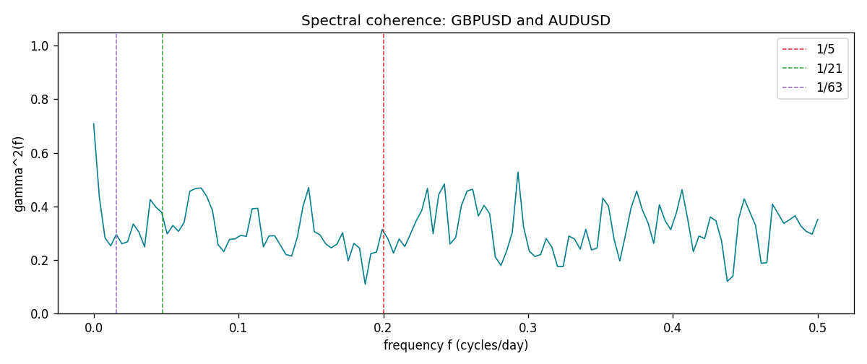

Data report
Matched rows and the coherence sheet are in the sibling Excel workbook named GBPUSD-AUDUSD_Spectral_D1.xlsx. Embedding all rows as a Word table is impractical; this file holds column summaries and the first and last 15 matched rows.
Columns: time, GBPUSD_open, AUDUSD_open, GBPUSD_high, AUDUSD_high, GBPUSD_low, AUDUSD_low, GBPUSD_close, AUDUSD_close, GBPUSD_tick_volume, AUDUSD_tick_volume, GBPUSD_spread, AUDUSD_spread, GBPUSD_real_volume, AUDUSD_real_volume, GBPUSD_log_return, AUDUSD_log_return
Column summaries (matched calculation rows)
column | count | mean | std | min | 25% | 50% | 75% | max
GBPUSD_open | 7228 | 1.5166822 | 0.21834818 | 1.06854 | 1.3254025 | 1.51196 | 1.63237 | 2.1066
AUDUSD_open | 7228 | 0.75192541 | 0.13534725 | 0.4785 | 0.66102 | 0.7315 | 0.8091975 | 1.10284
GBPUSD_high | 7228 | 1.5229801 | 0.21891417 | 1.08366 | 1.3300275 | 1.518725 | 1.638825 | 2.1161
AUDUSD_high | 7228 | 0.75597511 | 0.13590934 | 0.4878 | 0.664695 | 0.734945 | 0.81552 | 1.10795
GBPUSD_low | 7228 | 1.5103473 | 0.21757706 | 1.03518 | 1.32009 | 1.50469 | 1.624985 | 2.0983
AUDUSD_low | 7228 | 0.74786335 | 0.13465689 | 0.4775 | 0.6577 | 0.72762 | 0.804475 | 1.0975
GBPUSD_close | 7228 | 1.5167386 | 0.2183035 | 1.06879 | 1.32568 | 1.51203 | 1.6324775 | 2.1065
AUDUSD_close | 7228 | 0.75196864 | 0.13532707 | 0.4786 | 0.6611875 | 0.731775 | 0.809315 | 1.10169
GBPUSD_tick_volume | 7228 | 94565.268 | 153330.81 | 62 | 9974.5 | 52775.5 | 91622.5 | 1273370
AUDUSD_tick_volume | 7228 | 77126.179 | 137934.11 | 109 | 5406 | 43250.5 | 71246.75 | 1234623
GBPUSD_spread | 7228 | 27.003182 | 19.183813 | 0 | 11 | 20 | 50 | 50
AUDUSD_spread | 7228 | 30.855562 | 16.875394 | 0 | 13 | 30 | 50 | 50
GBPUSD_real_volume | 7228 | 3.5428062e+09 | 8.4280615e+10 | 0 | 0 | 0 | 0 | 2.4038164e+12
AUDUSD_real_volume | 7228 | 5.2225089e+09 | 1.2514647e+11 | 0 | 0 | 0 | 0 | 3.811512e+12
GBPUSD_log_return | 7228 | -2.954e-05 | 0.0056473 | -0.08388241 | -0.00313242 | 3.002e-05 | 0.00317333 | 0.03112653
AUDUSD_log_return | 7228 | 1.629e-05 | 0.00754363 | -0.08602525 | -0.00386494 | 0.00027649 | 0.00415111 | 0.0806166
First 15 matched rows (selected columns)
time | GBPUSD_log_return | AUDUSD_log_return
1999-01-05 | -0.0028966287 | -0.00080418179
1999-01-06 | -0.00060452184 | 0.011836351
1999-01-07 | -0.002118709 | 0.0088650256
1999-01-08 | -0.0058954193 | 0.00031515916
1999-01-11 | -0.0056851331 | 0.0072213815
1999-01-12 | 0.0022657001 | -0.0048608485
1999-01-13 | 0.0091330396 | -0.0078902098
1999-01-14 | 0.0019376331 | -0.002696916
1999-01-15 | -0.0017558204 | 0.007123101
1999-01-18 | 0.0012112405 | 0.00094592471
1999-01-19 | 0.0018745281 | 0.0072225153
1999-01-20 | -0.0049053846 | 0.0012507819
1999-01-21 | 0.0031518998 | 0.00078094498
1999-01-22 | 0.0024781662 | -0.012252745
1999-01-25 | 0.0012066366 | -0.0039591468
Last 15 matched rows (selected columns)
time | GBPUSD_log_return | AUDUSD_log_return
2026-10-13 | 0.0036434319 | 0.0035007712
2026-10-14 | -0.0049164679 | -0.0015193215
2026-10-15 | 0.0065976411 | -0.0075447063
2026-10-16 | 0.0037592051 | 0.0033906408
2026-10-19 | -0.0017500314 | 0.0050859986
2026-10-20 | 0.0055923442 | 0.0034620426
2026-10-21 | 0.0012476328 | 0.0036066384
2026-10-22 | 0.00022396082 | -0.0012672558
2026-10-23 | -0.0021146949 | 0.0023765656
2026-10-26 | -0.0024340661 | -0.0032032829
2026-10-27 | -0.0023648393 | 0.0016669876
2026-10-28 | 0.0015771808 | 0.0040915541
2026-10-29 | 0.0035881935 | -0.0040915541
2026-10-30 | 0.0013450605 | 0.0010102376
2026-11-02 | 0.0010971256 | -0.0049184984
First 15 frequency bins
f | gamma2 | phase_rad | period_days
0 | 0.70845772 | 0 | inf
0.00390625 | 0.43492939 | 0.23325437 | 256
0.0078125 | 0.28286313 | 0.4549083 | 128
0.01171875 | 0.25281415 | 0.42656921 | 85.333333
0.015625 | 0.29495112 | 0.39564406 | 64
0.01953125 | 0.26040895 | 0.29824509 | 51.2
0.0234375 | 0.26807427 | -0.03725721 | 42.666667
0.02734375 | 0.33428825 | 0.1628656 | 36.571429
0.03125 | 0.30412009 | 0.23960263 | 32
0.03515625 | 0.24866805 | 0.29097101 | 28.444444
0.0390625 | 0.42559589 | 0.05042537 | 25.6
0.04296875 | 0.39723087 | 0.05715044 | 23.272727
0.046875 | 0.37806377 | 0.15553858 | 21.333333
0.05078125 | 0.2973583 | 0.2748688 | 19.692308
0.0546875 | 0.32887856 | 0.12475219 | 18.285714

